PAID ASSIGNMENT SERVICES are AVAIBLE
- CS506
- Cs411
- CS403
- CS504
- CS604
0304-1659294
LMS HANDLING ALSO

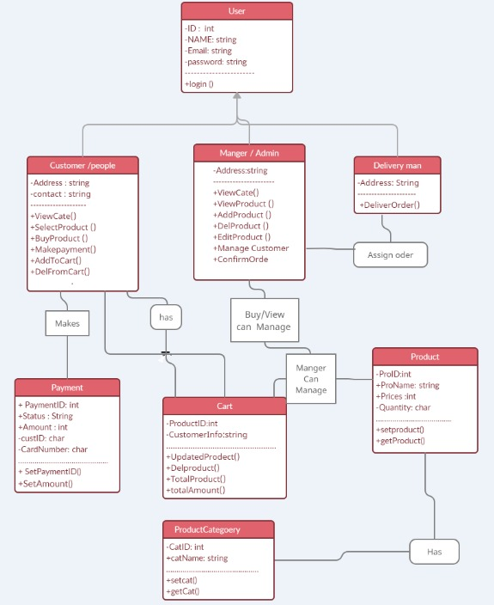
SOLUTION:
Donot Copy Papse

